**COMPLETE THE FOLLOWING TASKS!**

1. Return the customer IDs of customers who have spent at least $110 with the staff member who has an ID of 2.

**Solution.1**

SELECT customer_id, staff_id,SUM(amount) FROM payment

where staff_id=2

group by customer_id

having sum(amount)>=110

order by customer_id

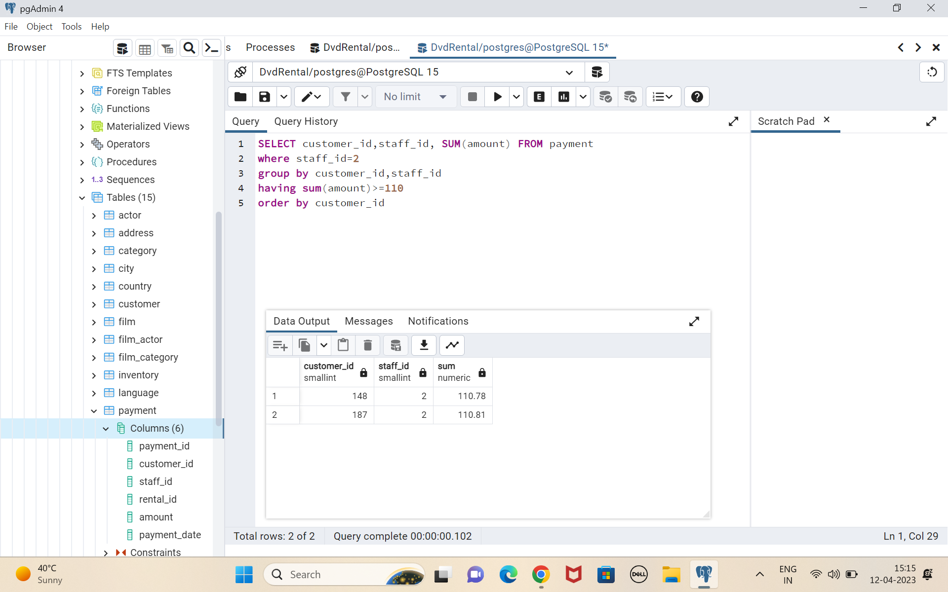

Q2 How many films begin with the letter J?

**Solution 2**

select* from film

where title Like'J%'

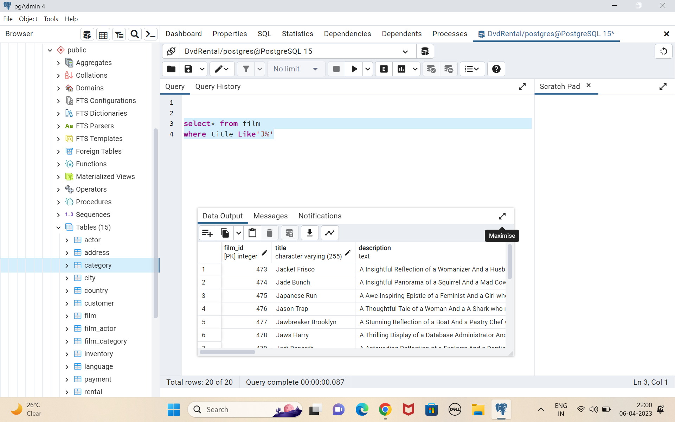

Q3. What customer has the highest customer ID number whose name starts **with** an 'E' **and** has an address ID lower than 500?

**Solution.3**

select customer_id, address_id ,concat(first_name||' '||last_name) As customer_name from public.customer

where first_name like 'E%' and address_id <500

order by customer_id DESC

Limit 1;

